Lab 7: Conceptual Database Design, ER Modeling, Relational Mapping, and Normalization

Theory
Database design is a systematic process of organizing data to ensure efficient storage, retrieval, consistency, and integrity. A well-designed database minimizes redundancy, prevents anomalies, and provides an effective way of managing large amounts of information. Relational Database Management Systems (RDBMS) such as MySQL use tables to store related data, where relationships between tables are established using keys and constraints.
Conceptual Database Design
Conceptual database design is the first stage of database development in which the overall structure of the database is planned without considering the implementation details of a specific DBMS. It identifies the major entities, their attributes, and the relationships among them based on the system requirements. The conceptual design provides a clear representation of the real-world environment that the database will model.
Entity-Relationship (ER) Model
The Entity-Relationship (ER) Model is a high-level conceptual data model used to visually represent the data requirements of a system. It describes the entities, their attributes, and the relationships between them using an ER diagram.
  - Entity
An entity is a real-world object or concept about which information is stored in the database. Examples include Student, Faculty, Research Project, Customer, Artist, and Painting.
  - Attribute
Attributes are the properties or characteristics that describe an entity. For example, a Student entity may have attributes such as StudentID, StudentName, Program, and Email.

  - Relationship
A relationship represents an association between two or more entities. Examples include:
- A faculty member supervises research projects.
- Students participate in research projects.
- Customers purchase paintings.
Relationships help define how data is connected within the database.
  - Cardinality
Cardinality specifies the number of instances of one entity that can be associated with another entity. Common cardinalities include:
- One-to-One (1:1)
- One-to-Many (1:N)
- Many-to-One (N:1)
- Many-to-Many (M:N)
  - Participation Constraint
Participation constraints determine whether participation of an entity in a relationship is mandatory (total participation) or optional (partial participation).
  - Weak Entity
A weak entity cannot be uniquely identified using its own attributes and depends on another entity for identification. It usually has a partial key and an identifying relationship with its owner entity.
  - Associative Entity
An associative entity is created to resolve a many-to-many relationship. It stores the foreign keys of the related entities along with any additional attributes describing the relationship. Examples from this lab include Student_Projects, Project_Funding, Project_Lab, Publication_Authors, and Student_Course.

Enhanced Entity-Relationship (EER) Model
The Enhanced Entity-Relationship (EER) model extends the basic ER model by incorporating additional concepts such as specialization, generalization, inheritance, and more complex constraints. It provides a more expressive representation for complex database systems while maintaining the simplicity of ER modeling.
Relational Database Schema
A relational schema is the logical representation of the database after converting the ER or EER model into relational tables. Each relation (table) consists of rows (tuples) and columns (attributes). Relationships between tables are maintained through keys.
The relational mapping process involves:
- Converting each entity into a table.
- Converting many-to-many relationships into separate tables.
- Representing one-to-many relationships using foreign keys.
- Defining primary keys and constraints.
Database Normalization
Normalization is the process of organizing data into multiple related tables to eliminate redundancy and maintain data integrity. It reduces insertion, deletion, and update anomalies.
- Un-Normalized Form (UNF)
UNF contains repeating groups and non-atomic attributes. Data is often stored in a single table, resulting in redundancy and inefficient data management.
- First Normal Form (1NF)
A relation is in First Normal Form when:
- Every attribute contains only atomic (indivisible) values.
- Repeating groups are removed.
- Each row is uniquely identifiable.
This improves consistency by ensuring every field stores only one value.
- Second Normal Form (2NF)
A relation is in Second Normal Form when:
- It is already in 1NF.
- Every non-key attribute is fully functionally dependent on the entire primary key.
- Partial dependencies are eliminated.
This decomposition reduces redundancy caused by composite keys.
- Third Normal Form (3NF)
A relation is in Third Normal Form when:
- It is already in 2NF.
- No transitive dependencies exist.
- Every non-key attribute depends only on the primary key.
Achieving 3NF improves consistency, simplifies maintenance, and minimizes data duplication.
- Boyce-Codd Normal Form (BCNF)
Boyce-Codd Normal Form (BCNF) is a stronger version of 3NF. A relation is in BCNF if:
- It is already in 3NF.
- For every functional dependency X → Y, X must be a candidate key.
BCNF removes anomalies that may still exist in some 3NF relations due to overlapping candidate keys.
- Fourth Normal Form (4NF)
A relation is in Fourth Normal Form (4NF) if:
- It is already in BCNF.
- It contains no non-trivial multivalued dependencies.
4NF eliminates situations where a single table stores multiple independent multivalued facts about the same entity, thereby reducing unnecessary duplication.
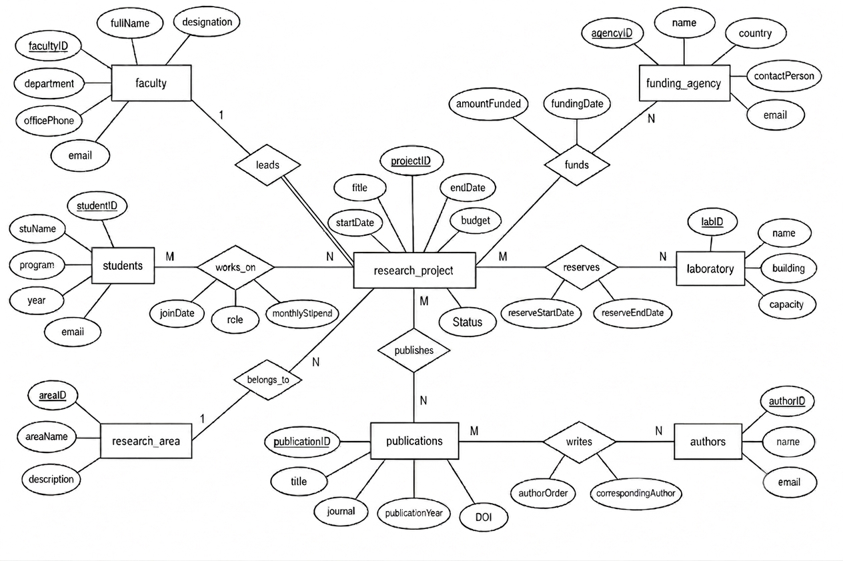
  - Draw a complete ER Diagram

- Convert the ER model into a relational database schema.
Relational Database Schema (EER model):
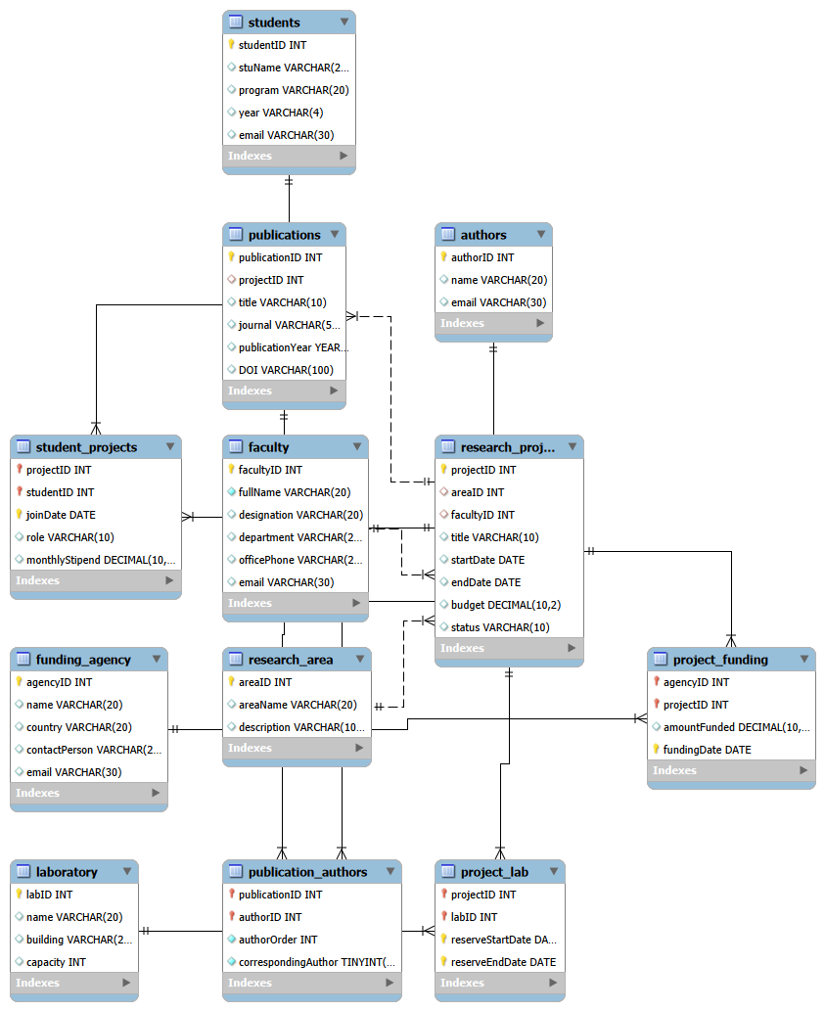

- Write SQL CREATE TABLE statements for any six important tables including
Source Code:
create database uni_research;
use uni_research;
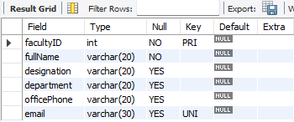
create table faculty (
facultyID int primary key not null,
fullName varchar(20) not null,
designation varchar(20),
department varchar(20),
officePhone varchar(20),
email varchar(30) unique
);

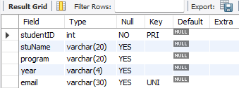
create table students(
studentID int primary key,
stuName varchar(20),
program varchar(20),
year varchar(4),
email varchar(30) unique
);

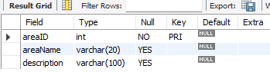
create table research_area(
areaID int primary key not null,
areaName varchar(20),
description varchar(100)
);

create table research_project(
projectID int primary key,
areaID int not null,
facultyID int not null,
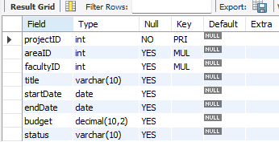
title varchar(100),
startDate date,
endDate date,
budget decimal(10,2),
status varchar(10),

foreign key (areaID)
references research_area(areaID),

foreign key(facultyID)
references faculty(facultyID)
);

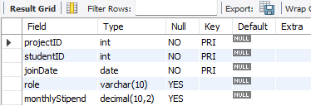
create table student_projects(
projectID int,
studentID int,
joinDate date,
role varchar(10),
monthlyStipend decimal(10,2),

primary key(projectID, studentID, joinDate),

foreign key (projectID)
references research_project(projectID),

foreign key (studentID)
references students(studentID)
);

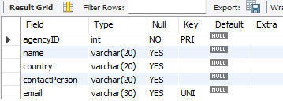
create table funding_agency(
agencyID int primary key,
name varchar(20),
country varchar(20),
contactPerson varchar(20),
email varchar(30) unique
);

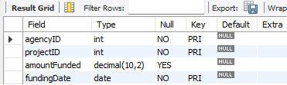
create table project_funding(
agencyID int,
projectID int,
amountFunded decimal(10,2),
fundingDate date not null,

primary key(agencyID, projectID, fundingDate),
foreign key(projectID)
references research_project(projectID),
foreign key(agencyID)
references funding_agency(agencyID)
);
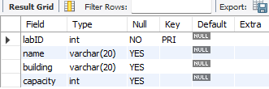
create table laboratory(
labID int primary key,
name varchar(20),
building varchar(20),
capacity int
);

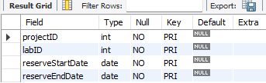
create table project_lab(
projectID int,
labID int,
reserveStartDate date,
reserveEndDate date,
primary key(projectID, labID, reserveStartDate, reserveEndDate),
foreign key(projectID)
references research_project(projectID),
foreign key(labID)
references laboratory(labID)
);
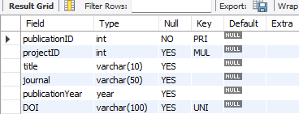
create table publications(
publicationID int primary key,
projectID int,
title varchar(10),
journal varchar(50),
publicationYear year,
DOI varchar(100) unique,

foreign key (projectID)
references research_project(projectID)
);

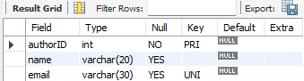
create table authors(
authorID int primary key,
name varchar(20),
email varchar(30) unique
);

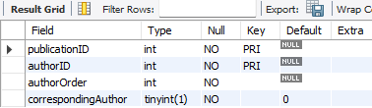
create table publication_authors(
publicationID int,
authorID int,
authorOrder int not null,
correspondingAuthor boolean not null default false,
primary key(publicationID, authorID),
foreign key (publicationID)
references publications(publicationID),
foreign key(authorID)
references authors(authorID)
);

- A training institute stores student enrollment information in a single spreadsheet.
- One student enrolls in many courses.
- One course has many students.
- One course is taught by one instructor in a semester.
- One instructor teaches many courses.
- One textbook is prescribed for one course.
- One textbook may be used by multiple courses.
  - Normalize the database into Third Normal Form (3NF). And design a relational database. Create a relational schema which should include the following informations:
- Relation name
- Attributes
- Primary Key
- Foreign Keys
Relational Schema representation using EER diagram:
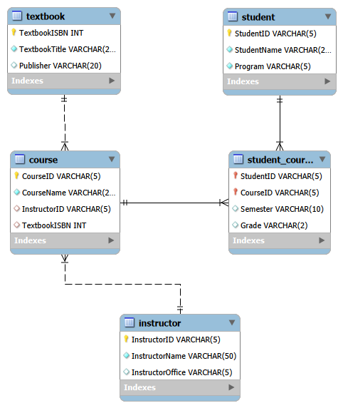
b) Write SQL CREATE TABLE statements for creating tables including
- Primary Keys
- Foreign Keys
- Appropriate data types
- NOT NULL constraints
Source Code:
create database training_institute;
use training_institute;

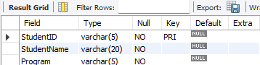
create table if not exists student (
StudentID varchar(5) primary key,
StudentName varchar(20) not null,
Program varchar(5) not null
);

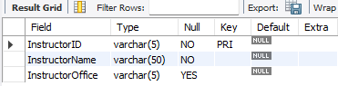
create table if not exists instructor(
InstructorID varchar(5) primary key,
InstructorName varchar(50) not null,
InstructorOffice varchar(5)
);

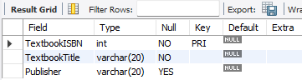
create table if not exists textbook(
TextbookISBN int primary key,
TextbookTitle varchar(20) not null,
Publisher varchar(20)
);

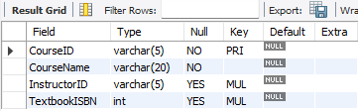
create table if not exists course(
CourseID varchar(5) primary key,
CourseName varchar(20) not null,
InstructorID varchar(5),
TextbookISBN int,

foreign key (InstructorID)
references instructor(InstructorID),

foreign key (TextbookISBN)
references textbook(TextbookISBN)
);


create table if not exists student_course(
StudentID varchar(5),
CourseID varchar(5),
Semester varchar(10),
Grade varchar(2),

primary key(StudentID, CourseID),

foreign key (StudentID)
references student(StudentID),

foreign key (CourseID)
references course(CourseID)
);

- Given the sample order form and description below, create the un-normalized form of the data and transform through the steps needed to move into normalized form.
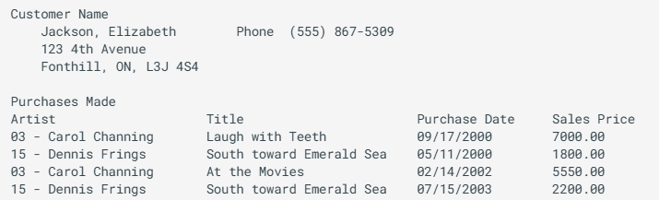
The Gill Art Gallery wishes to maintain data on their customers, artists and paintings. They may have several paintings by each artist in the gallery at one time. Paintings may be bought and sold several times. In other words, the gallery may sell a painting, then buy it back at a later date and sell it to another customer.

Un-normalized form:
gill_gallery
(customer_id​, customer_name, phone, street, city, state, postal_code, {artist_id, artist_name, title, purchase_date, sales_price})
(The curly braces $\left\{…\right\}$ represent the repeating group of purchases.)

First Normal Form (1NF)
Eliminating repeating groups so that every attribute contains only atomic values
gill_gallery_1nf
(customer_id​, artist_id​, title​, purchase_date​, customer_name, phone, street,city, state, postal_code, artist_name, sales_price)
Primary Key: (customer_id, artist_id, title, purchase_date)

Second Normal Form (2NF)
Must be in 1NF and eliminate Partial Functional Dependencies (where a non-key attribute depends on only a part of the composite primary key).
Table 1: customer
customer_id | customer_name | phone | street | city | state | postal_code
Primary Key: customer_id
Table 2: artist
artist_id | artist_name
Primary Key: artist_id
Table 3: painting
painting_id | title | artist_id (FK)
Primary Key: painting_id
Table 4: customer_purchase
purchase_id | customer_id (FK) | painting_id  (FK) | purchase_date | sales_price
Primary Key: purchase_id
Foreign Keys:
customer_id -> customer (customer_id)
painting_id -> painting (painting_id)

Third Normalization Form (3NF)
In each decomposed 2NF table, all non-key attributes depend only on the primary key. There are no transitive dependencies. The schema is fully in 3NF.

  - Design a relational database. Create a relational schema which should include the following information:
- Relation name
- Attributes
- Primary Key
- Foreign Keys
Relational Schema representaiton using EER Diagram:
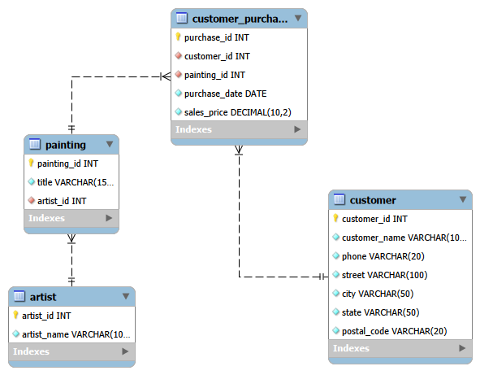

  - Write SQL CREATE TABLE statements for creating tables including
- Primary Keys
- Foreign Keys
- Appropriate data types
- NOT NULL constraints

Source Code:
-- create database
create database if not exists gill_art_gallery;
use gill_art_gallery;

-- 1. create customer table
create table customer (
customer_id int auto_increment primary key,
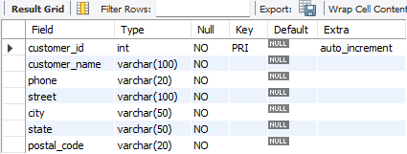
customer_name varchar(100) not null,
phone varchar(20) not null,
street varchar(100) not null,
city varchar(50) not null,
state varchar(50) not null,
postal_code varchar(20) not null
);

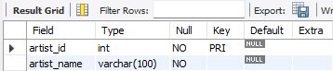
-- 2. create artist table
create table artist (
artist_id int primary key,
artist_name varchar(100) not null
);


-- 3. create painting table
create table painting (
painting_id int auto_increment primary key,
title varchar(150) not null,
artist_id int not null,
foreign key (artist_id) references artist(artist_id)
on update cascade on delete restrict
);

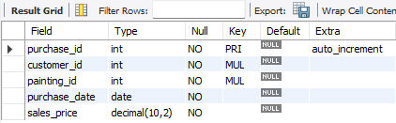
-- 4. create customer_purchase table
create table customer_purchase (
purchase_id int auto_increment primary key,
customer_id int not null,
painting_id int not null,
purchase_date date not null,
sales_price decimal(10, 2) not null,
foreign key (customer_id) references customer(customer_id)
on update cascade on delete cascade,
foreign key (painting_id) references painting(painting_id)
on update cascade on delete restrict
);

Conclusion
In this lab, conceptual database design techniques were applied to develop relational database schemas using ER/EER modeling and normalization. The designed schemas were implemented using SQL DDL statements with appropriate keys and constraints. Through this lab, practical knowledge was gained in designing efficient relational databases, converting ER models into relational schemas, applying normalization principles, and creating database tables while ensuring data integrity and minimizing redundancy.

